Smart Thermostat - Partner Social Media
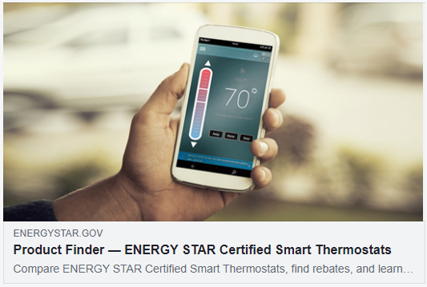
Instructions:
1. When linking to www.energystar.gov/smartthermostats or the Product Finder
on Facebook and Twitter, an image will auto-populate (see example to the right).
2. Please do not use link shortening services for energystar.gov links as it interferes
with our web traffic tracking. Instead, please use the full links, or the alias links
provided in the spreadsheet below. Twitter will automatically shorten the longer links.
3. Remember to tag ENERGY STAR. On Twitter, simply type "@ENERGYSTAR".
On Facebook, begin typing "@ENERGY STAR" and choose the ENERGY STAR
Facebook Page from the drop down list.
Download supporting social media imagery at www.energystar.gov/marketing_materials
Topic | Social media post
Overview | The average household spends about half of its energy bill on heating & cooling—more than $900/yr! Be smart about your heating with an @ENERGYSTAR certified smart thermostat to save money, stay comfortable, and help protect the planet. www.energystar.gov/smartthermostats
Overview | What is a smart thermostat? It's is a Wi-Fi enabled device that can automatically adjust temperature settings for optimal performance. @ENERGYSTAR smart thermostats have been independently certified, based on actual field data, to save you energy & money. https://www.energystar.gov/products/heating_cooling/smart_thermostats
Overview | Get smart about how to control your home's temperature control and comfort! Find an @ENERGYSTAR certified smart thermostat that's right for you and save energy, money, and the environment. Save more with rebates. www.energystar.gov/smartthermostats
Key Product Messaging | Make the simple choice with an @ENERGYSTAR certified smart thermostat. With the ENERGY STAR label, you get a thermostat that has been independently tested to deliver reliable performance, energy savings, and environmental benefits. Save more with rebates. www.energystar.gov/smartthermostats
Key Product Messaging | Why choose an @ENERGYSTAR certified smart thermostat?  - Demonstrated energy savings  - Reliable performance  - Environmental benefits  - Convenience, insight, and control  https://www.energystar.gov/products/heating_cooling/smart_thermostats
Key Product Messaging | Control your home's temperature, and your energy savings, right from your smartphone with an @ENERGYSTAR smart thermostat. Smart for you and the planet. www.energystar.gov/smartthermostats
Key Product Messaging | An @ENERGYSTAR certified smart thermostat learns the temperature that you like and establishes a schedule that automatically adjusts to energy-saving temperatures when you are asleep or away. Smart for you and the planet. www.energystar.gov/products/smart_thermostats_infographic
Key Product Messaging | An @ENERGYSTAR certified smart thermostat provides convenience, insight, and control. Control them right from your smartphone and receive home energy use data that you can track and manage. Smart for you and the planet. www.energystar.gov/smartthermostats
Environmental Benefits | If everyone used an @ENERGYSTAR certified smart thermostat, we would save about $740 million dollars in energy costs and 13 billion pounds of annual greenhouse gas emissions that contribute to climate change. Make your difference today with ENERGY STAR. www.energystar.gov/products/smart_thermostats_infographic
Promotional Messaging | ENERGY STAR certified smart thermostats use less energy to keep you comfortable inside, which helps protect the environment outside. For energy and money savings and the perfect climate all around, look for the @ENERGYSTAR label. Save more with rebates. www.energystar.gov/smartthermostats
Promotional Messaging | No matter how you enjoy the season, you can count on an @ENERGYSTAR certified smart thermostat to save energy and money and protect the planet while keeping your home cozy. For a perfect climate inside and out, look for the ENERGY STAR label. www.energystar.gov/smartthermostats
Promotional Messaging | Spend more time creating memories and less time worrying about your energy bill. @ENERGYSTAR smart thermostats save energy and keep you comfortable all year round. For a perfect climate inside and out, look for the @ENERGYSTAR label. www.energystar.gov/smartthermostats

