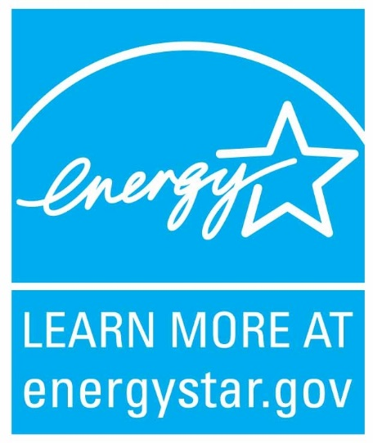

Dear (congregational decision-maker),
My workplace (fill in the blank) has partnered with the U.S. Environmental Protection Agency’s voluntary ENERGY STAR program to save energy, save money and reduce the greenhouse gas emissions for which our facility is responsible. As a congregation member, I care about our mission and financial priorities, as well as what our faith teaches about stewardship of the earth and not being wasteful.
By saving energy and money, our congregation can help reduce pollution harmful to human health and protect natural resources for future generations. ENERGY STAR has documented - working with the faith community, Fortune 500 corporations, school districts and local governments - that we all can continually improve our energy efficiency with strategic energy management. ENERGY STAR can even help our members save money in their homes and businesses.
At no cost to our congregation, ENERGY STAR offers tools, training, technical support and public recognition to help achieve energy savings. EPA’s Portfolio Manager® energy performance tool has a special module for worship facilities, and our congregation can join ENERGY STAR as a partner. Also, the new ENERGY STAR Action Workbook for Congregations is a free download, along with a new worship facilities tip sheet and other resources - at www.energystar.gov/congregations.
If you have questions, or need further information, please let me know or contact ENERGY STAR at 1-(888) STAR-YES and ask for their congregations program manager to call you.
Sincerely,
(your name here)

