General Messaging
Make the most of every life moment by lighting them with ENERGY STAR certified lighting. Only LED bulbs and fixtures that earn the ENERGY STAR label are independently certified to deliver high quality, save energy, and help protect the environment. Now there’s a perfect light for every room of your home, including specialty bulbs and downlight fixtures, so you can light every moment wherever they happen and enjoy the savings.

Light every moment throughout your home with ENERGY STAR certified lighting. Only LED bulbs and fixtures that have earned the ENERGY STAR deliver:
- Quality: Whatever the moment, there’s an ENERGY STAR certified LED light perfect for maximizing the impact.
- Light Distribution: ENERGY STAR certified LED bulbs and fixtures light the small, intimate moments AND the big, busy ones.
- Long-Life: Lasting over 13 years, ENERGY STAR certified lighting will be there for all of your special moments wherever they happen.
- A Better Planet: Protecting the climate for future generations so we can continue to experience special moments for years to come.

Supporting Campaign Messaging:
- Whatever and wherever the life moment, there’s an ENERGY STAR certified lighting product that will help make it perfect, with the quality performance, savings, and environmental protection you desire.
- Only ENERGY STAR certified LED bulbs and fixtures are certified to deliver:
  - Highest quality performance
  - Just the right brightness and color
  - Big energy savings—Last 13+ Years!
  - A Better Planet
- Use the ENERGY STAR Choose a Light Guide to find the perfect bulb shape, color, and brightness to light the moment in every room of your home. www.energystar.gov/choosealight.
- If every American home replaced just one light bulb with one that has earned the ENERGY STAR, we would prevent more than 7 billion pounds of greenhouse gas emissions per year, equivalent to the emissions from approximately 675,000 cars.
- Purchasing ENERGY STAR certified LED lighting is the simple choice for consumers who want to save energy, save money, and protect the climate.

General Lighting Messaging
- It’s simple: look for the ENERGY STAR for energy savings. No matter the technology or the performance claims, only bulbs and fixtures with the ENERGY STAR label meet strict guidelines for efficiency and performance that set them apart.
- ENERGY STAR certified LED bulbs and fixtures come in all shapes, sizes, and styles to fit every room in your home. They include everything from general purpose bulbs, to accent and under cabinet lighting, recessed cans, outdoor lighting, and even ceiling fans. Whatever and wherever the moment, there is an ENERGY STAR certified light to make it perfect.
- ENERGY STAR certified lighting is available in a variety of shades of light, allowing you to customize the mood of your space. Available shades range from a soft, warm glow that matches traditional lighting to a cooler, crisper light that can help enhance blue shades. Choose the same “light appearance number” (e.g., 2700K to match traditional light color) for bulbs or fixtures in the same room. If you’re looking to enhance features in your home, such as the entryway, granite countertops, or even artwork, ENERGY STAR certified LED bulbs and fixtures will provide the perfect light.

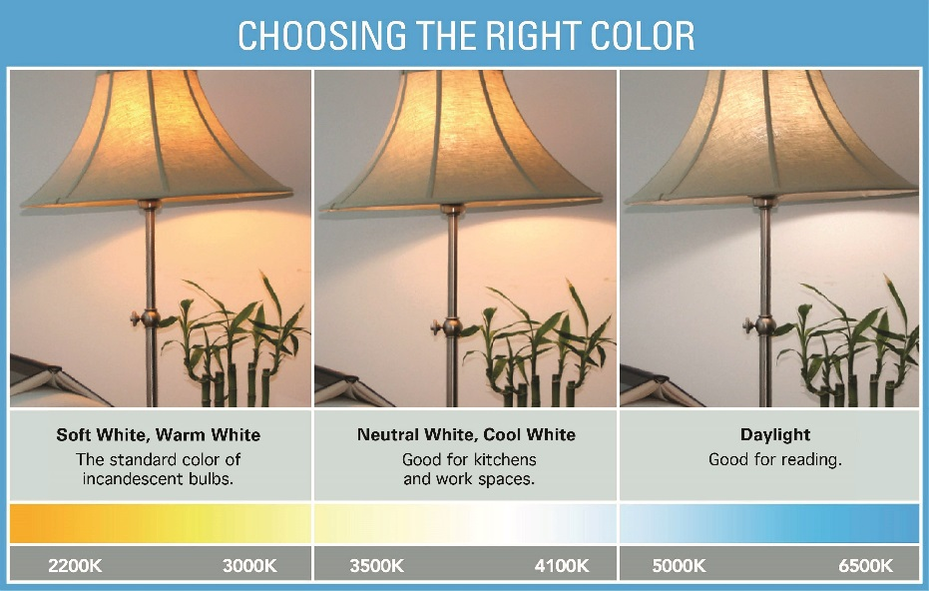

- Most ENERGY STAR certified LED bulbs and fixtures are dimmable. Make sure to look for the dimming information on the package and install dimmer switches that are compatible with the bulbs or fixtures you choose.
- Many outdoor fixtures that have earned the label feature motion sensors that shut them off automatically in daylight.
- LED bulbs and fixtures are changing the way Americans light their homes, and ENERGY STAR is at the heart of the transition. Only lighting products that have earned the ENERGY STAR are certified to deliver the quality and energy savings you expect at a price everyone can afford.

Savings:
- ENERGY STAR certified LED bulbs use up to 90% less energy than standard bulbs and last 15 times longer.
- A single light bulb that has earned the ENERGY STAR can save more than $50 in electricity costs over its lifetime, and even more with fewer bulb replacements since they last 13+ years.
- Candle and globe-shape ENERGY STAR certified LED bulbs use approximately 85% less energy than standard bulbs, saving more than $45 over the products’ lifetime.
- Reflector shape ENERGY STAR certified LED bulbs use approximately 80% less energy than standard bulbs, saving more than $70 over the products’ lifetime.
- By replacing your home's five most frequently used light fixtures or the bulbs in them with models that have earned the ENERGY STAR, you can save nearly $45 each year.
- If every American home replaced just one light bulb with one that has earned the ENERGY STAR, we would save enough energy to light 3.6 million homes for a year and save nearly $560 million in annual energy costs.
- With prices dropping rapidly across the country, LED lighting is becoming the best choice for every American, offering long life and energy savings that will save consumers money while making a difference for the planet.

Environmental Benefits:
- If every American home replaced just one light bulb with one that has earned the ENERGY STAR, we would prevent nearly 7 billion pounds of greenhouse gas emissions per year, equivalent to the emissions from approximately 675,000 cars.
- Replace a bulb and reduce your carbon footprint.
  - A single light bulb that has earned the ENERGY STAR prevents, on average, 795 pounds of greenhouse gas emissions over its lifetime.
  - Candle and globe-shaped ENERGY STAR certified LED bulbs save 700 pounds of greenhouse gas emissions over the products’ lifetime.
  - Reflector shape ENERGY STAR certified LED bulbs save 1,100 pounds of greenhouse gas emissions over the products’ lifetime.
Quality and Performance:
- Only bulbs and fixtures that have earned the ENERGY STAR label have been independently certified and undergone extensive testing to ensure that they will save energy and perform as promised.
- To earn the ENERGY STAR, LED bulbs must demonstrate they can meet consumer expectations, delivering on brightness, color quality, and being able to shine light in all directions.
- Before they can carry the label, ENERGY STAR certified lighting products are subject to thorough testing and review:
  - Compliance with more than 20 separate industry standards and procedures is verified.
  - Rapid cycling of every product model is performed thousands of times to prevent early failures.
  - High heat testing is performed to expose these products to operating environments similar to actual consumer use.
  - Minimum 3-year warranties for LED bulbs.
- The performance of ENERGY STAR lighting is certified by independent third parties based on testing in EPA-recognized laboratories.
ENERGY STAR Certified Fixtures:
- Now you can brighten all the moments throughout your home with an ENERGY STAR certified light perfect for every room.
- ENERGY STAR certified light fixtures are now available with standard, screw-in sockets. Each comes packaged with a long-lasting, energy-saving bulb.
- Look for cool new ENERGY STAR certified fixtures that come with LED light sources integrated into the fixture design.
- ENERGY STAR certified LED fixtures are a simple choice for savings and quality. Bulbs and fixtures that have earned the ENERGY STAR use up to 90% less energy than standard bulbs and last 15 times longer.
- Ceiling fans with lights that have earned the ENERGY STAR are 60% more efficient than conventional fan/light units, saving you $120 in energy costs over the fan’s 14-year lifetime.
- Selecting the right ENERGY STAR certified LED fixture is easy—there’s a variety of options for most lighting needs and they are available in designs to fit any décor.
- ENERGY STAR certified LED recessed downlight kits make it simple to upgrade existing recessed fixtures or install new energy efficient recessed lighting in your home.
  - The lights in these kits are designed specifically for downlight applications and provide optimal energy efficiency for this use. ENERGY STAR certified kits use up to 90% less energy than standard downlights, which means that each fixture can save you more than $80 over its lifetime.
  - Recessed downlights that earn the ENERGY STAR label are tested to ensure they have a lifetime of at least 25,000 hours—that’s 25 times longer than a traditional light bulb. With average use, you should not have to worry about replacing them for more than 20 years.
  - If you already have recessed downlights, choosing an ENERGY STAR certified retrofit kit instead of switching out the bulb is a design-grade addition that will save more energy and last longer. These kits also make it easy to find a compatible light. Instead of choosing from a variety of bulb shapes and sizes, look for the diameter that matches your existing fixture.

