General Messaging
Make the most of every life moment by lighting them with ENERGY STAR certified LED bulbs. Only LED bulbs that have earned the ENERGY STAR label are independently certified to deliver high quality, save energy, and help protect the environment.

Light your moments with ENERGY STAR certified LED bulbs. LED bulbs that have earned the ENERGY STAR deliver:
- Quality: Whatever the moment, there’s an ENERGY STAR certified LED light perfect for maximizing the impact.
- Light Distribution: ENERGY STAR certified LED bulbs light the small, intimate moments AND the big, busy ones.
- Long-Life: Lasting over 13 years, ENERGY STAR certified LED bulbs will be there for all of your special moments.
- Environmental Protection: Protecting the planet for future generations so we can continue to experience special moments for years to come.

Supporting Campaign Messaging:
- Whatever the life moment, there’s an ENERGY STAR certified LED lighting product that will help make it perfect, with the quality performance, savings, and environmental protection you desire.
- Only ENERGY STAR certified LED bulbs are certified to deliver:
  - Highest quality performance
  - Just the right brightness and color
  - Big energy savings—last 13+ years!
  - Environmental benefits
- Use the ENERGY STAR Choose a Light Guide to find the right bulb shape, color, and brightness to light your moment. Find your bulb at www.energystar.gov/choosealight.
- If every American home replaced just one light bulb with one that has earned the ENERGY STAR, we would prevent nearly 7 billion pounds of greenhouse gas emissions per year, equivalent to the emissions from approximately 670,000 cars.
- Purchasing ENERGY STAR certified LED lighting is the simple choice for consumers who want to save energy, save money, and protect the environment from climate change.

General Lighting Messaging
- It’s simple: look for the ENERGY STAR for energy savings. No matter the technology or the performance claims, only bulbs with the ENERGY STAR label meet strict guidelines for efficiency and performance that set them apart.
- With prices dropping rapidly across the country, LED lighting is becoming the simple option for every American, offering long life and energy savings that will save consumers money while making a difference for the planet.
- LED lighting is changing the way Americans illuminate their homes, and ENERGY STAR is at the heart of the transition. High-quality ENERGY STAR certified LED light bulbs and fixtures are now more affordable than ever.

Savings:
- ENERGY STAR certified LED bulbs use up to 90% less energy than standard bulbs and last 15 times longer.
- A single light bulb that has earned the ENERGY STAR can save more than $55 in electricity costs over its lifetime.
- By replacing your home's five most frequently used light fixtures or the bulbs in them with models that have earned the ENERGY STAR, you can save about $45 each year.
- If every American home replaced just one light bulb with one that has earned the ENERGY STAR, we would save enough energy to light 3.5 million homes for a year and save more than $570 million in annual energy costs.
- A decorative light string that has earned the ENERGY STAR uses 75 percent less energy than an incandescent light string.
- Ceiling fans with lights that have earned the ENERGY STAR are 60 percent more efficient than conventional fan/light units, saving you $130 in energy costs over the fan’s 14-year lifetime.

Environmental Benefits:
- If every American home replaced just one light bulb with one that has earned the ENERGY STAR, we would prevent nearly 7 billion pounds of greenhouse gas emissions per year, equivalent to the emissions from approximately 670,000 cars.
- Replace a bulb and reduce your carbon footprint. A single light bulb that has earned the ENERGY STAR prevents, on average, 795 pounds of greenhouse gas emissions over its lifetime.
Quality and Performance:
- Only bulbs that have earned the ENERGY STAR label have been independently certified and undergone extensive testing to ensure that they will save energy and perform as promised.
- To earn the ENERGY STAR, LED bulbs must demonstrate they can meet consumer expectations, delivering on brightness, color quality, and being able to shine light in all directions.
- Before they can carry the label, ENERGY STAR certified lighting products are subject to thorough testing and review:
  - Compliance with more than 20 separate industry standards and procedures is verified.
  - Rapid cycling of every product model is performed thousands of times to prevent early failures.
  - High heat testing is performed to expose these products to operating environments similar to actual consumer use.
  - Minimum 3-year warranties for LED bulbs.
- The performance of ENERGY STAR lighting is certified by independent third parties based on testing in EPA-recognized laboratories.
- ENERGY STAR certified LED bulbs and fixtures come in all shapes and sizes. They include everything from general purpose bulbs, to accent and under cabinet lighting, recessed cans, and outdoor lighting. If you’re looking to enhance features in your home, such as the entryway, granite countertops, or even artwork, ENERGY STAR certified LED bulbs and fixtures are up to the task.
- ENERGY STAR certified lighting is available in a variety of shades of light, allowing you to customize the mood of your space. Available shades range from a soft, warm glow that matches traditional lighting to a cooler, crisper light that can help enhance blue shades. Choose the same “light appearance number” (e.g. 2700K to match traditional light color) for bulbs or fixtures in the same room.

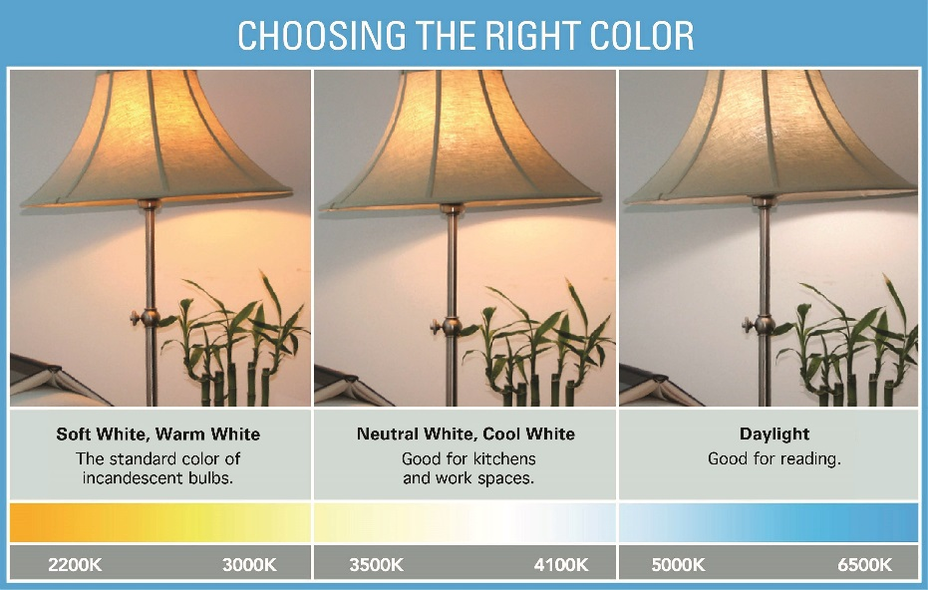

- Most ENERGY STAR certified LED bulbs and fixtures are dimmable. Make sure to look for the dimming information on the package and install dimmer switches that are compatible with the bulbs or fixtures you choose.
- Many outdoor fixtures that have earned the label feature motion sensors that shut them off automatically in daylight.
ENERGY STAR Certified Fixtures:
- ENERGY STAR certified light fixtures are now available with standard, screw-in sockets. Each comes packaged with a long-lasting, energy-saving bulb.
- Look for cool new ENERGY STAR certified fixtures that come with LED light sources integrated into the fixture design.
- ENERGY STAR certified LED fixtures are a simple choice for savings and quality. Bulbs and fixtures that have earned the ENERGY STAR use up to 90% less energy than standard bulbs and last 15 times longer.
- Selecting the right ENERGY STAR certified LED fixture is easy—there’s a variety of options for most lighting needs.
- ENERGY STAR certified LED fixtures are available in designs to fit any décor.

Useful Resources:
- ENERGY STAR Lighting Website: www.energystar.gov/lighting
- ENERGY STAR Light Bulbs Website: www.energystar.gov/lightthemoment
- Interactive Choose a Light Guide (mobile friendly): www.energystar.gov/choosealight
- Lifetime Savings: English | Spanish
- Co-brandable Lighting Factsheet (with purchasing guide) English | Spanish
- Lighting Made Easy Stand Alone Mark for LEDs: English | Spanish
- Renovation with ENERGY STAR Certified LED Lighting: English (937KB) | Spanish (319KB)
- Guide to Dimmables: English (1.4MB) | Spanish (4.5MB)
- ENERGY STAR Certified Fixtures: Information

