The following specification stipulates that a commercial new construction building project and the completed building meets the U.S. Environmental Protection Agency’s (EPA) energy performance criteria to achieve ENERGY STAR® certification. Commercial new construction and major renovation projects may be eligible to receive the Designed to Earn the ENERGY STAR recognition, which denotes that the operating energy use of the building is designed to be in the top 25 percent as compared to similar buildings throughout the U.S. Once the project is constructed, operated, and occupied for at least eleven months, the building may be eligible for ENERGY STAR certification as an existing building.
Instructions for using this document
This document may be modified to suit various transactions; a client may incorporate it in a request for proposal, in the contractual arrangement between the client and architecture firm, in construction documents, and in a lease agreement. When included in project construction documents, the specification may be incorporated as a drawing specification or within the General Requirements section of the project manual. The specification includes language applicable to the project design phase, construction phase, and performance of the occupied building. See Figure 1 for graphic on when to use ENERGY STAR during design process.
Including this building energy performance specification to achieve an ENERGY STAR score of 75 or higher is a simple step towards designing, constructing, and operating a building with superior energy performance — one whose energy use, greenhouse gas emissions, and costs-to-operate are lower than comparable buildings nationwide.

Recommended language for designer scope of work or request for proposal
Environmental and Sustainability Goals
The goal for this commercial new construction building project is to achieve EPA ENERGY STAR certification. The project designer shall use the EPA’s Target Finder or Portfolio Manager online tool to evaluate the project design to achieve an ENERGY STAR score of 75 or higher. The designer shall prepare and submit application to the EPA upon completion of the construction document phase on projects eligible for EPA’s Designed to Earn the ENERGY STAR certification.
Upon EPA’s award of the Design to ENERGY STAR certification, the designer shall provide documentation verifying certification to [the project owner] and where applicable transfer the Designed to Earn the ENERGY STAR project record to [the project owner’s] Portfolio Manager account. A copy of the original Statement of Energy Design Intent signed and sealed by a licensed engineer or registered architect shall be provided to [the project owner] as evidence that the energy design intent met or exceeded ENERGY STAR performance levels.
Pre-design or programming phase
The design team shall conduct a charrette with a multi-disciplinary team, including but not limited to architect, mechanical engineer, building energy modeler, commissioning agent, building owner, construction manager, and contractor to address a comprehensive approach to energy efficiency through an integrated design process. The design team shall assist the owner in developing a scope of work, project budget and schedule, a whole-building energy performance target that meets
or exceeds an ENERGY STAR score of 75, generated by the EPA’s Target Finder or Portfolio Manager tool. The design team shall consult with the building owner to develop accurate estimates for the anticipated occupancy and use of the property with the understanding that these variables will impact the ENERGY STAR score. All references for use of the ENERGY STAR score are dependent on property types eligible to earn a 1 – 100 ENERGY STAR score.
Schematic design phase
Design team members shall explore strategies and develop an energy model where the whole building energy performance of the preliminary design meets or exceeds an ENERGY STAR score of 75 or greater. Energy performance of the schematic design shall be adjusted and evaluated using Target Finder or Portfolio Manager to achieve an ENERGY STAR score of 75 or greater as established in the pre-design phase.
Design development
Design team members shall fine tune original design strategies and methodologies. Energy performance and property use details shall be adjusted per input from the building owner and all design team members and evaluated using Target Finder or Portfolio Manager to achieve an ENERGY STAR score of 75 or greater during design development.
Construction documents
Design team members shall fully develop and document energy performance strategies and methodologies for the project. The design team shall review progress and adjust strategies and systems to meet or exceed the ENERGY STAR score established for building design. If not completed already, the design team shall create a property record using Portfolio Manager to facilitate applying for Designed to Earn the ENERGY STAR recognition.
Specification content: The specifications in the Project Manual shall include and reference the “Statement of Energy Design Intent,” generated from Portfolio Manager at completion of construction document phase. A copy of the original Statement of Energy Design Intent signed and sealed by a licensed engineer or registered architect shall be provided to [the project owner] as evidence of the application to EPA, showing that the energy design intent meets or exceeds ENERGY STAR performance levels. Reference the application instructions for Designed to Earn the ENERGY STAR to submit projects to EPA.
Upon EPA’s award for achieving certification, the architect of record may insert the Designed to Earn the ENERGY STAR mark in the construction documents and/or title block on drawings. The graphic may also be used in other collateral and promotional materials for the approved project.
The design property record shall be maintained in the project owner’s ENERGY STAR Portfolio Manager account. The same property record shall be used for tracking energy data once the building is operating to determine if the intended energy design goal was achieved.
Recommended specification language for contractors, commissioning agents, and building managers
Construction contractor section
This project is designed to achieve an ENERGY STAR score of 75 or greater. The architect of record has included the Statement of Energy Design Intent, generated from EPA’s Portfolio Manager, and submitted an application for Designed to Earn the ENERGY STAR. The contractor shall adhere to products, methods, and quality levels specified in the construction documents. Any proposed substitutions affecting building energy performance must be submitted according to the procedures defined herein. Substitutions that may alter the energy performance goals of the project, including but not limited to HVAC equipment, insulation, cladding, and windows, and lighting must be approved by the design team and building owner. Any substitutions that would render the project ineligible for ENERGY STAR certification will not be approved.
Commissioning section
The owner shall employ a commissioning agent (independent of the design team) to document confirmation that building systems function in compliance with the energy performance goals set forth in the project documents and satisfy the owner's operational goals. The commissioning agent shall perform tests and document procedures necessary to verify compliance with intended operation of specified systems. The commissioning responsibilities are indicated within the construction documents and individual specification sections. The commissioning agent shall measure and track actual energy consumption of the building’s systems to determine if energy performance goals are being achieved and maintained. The commissioning agent shall work with the contractor to make needed adjustments and corrections prior to expiration of the warranty period.
Building management contract or tenant lease (Post Occupancy)
It is the intent of the building owner that ENERGY STAR certification shall be pursued in no less than eleven months of operation, meet or exceed the occupancy requirements set forth by EPA and the building qualifies as a property types eligible to earn a 1 – 100 ENERGY STAR score. The building’s annual energy use shall be benchmarked using ENENRGY STAR’s Portfolio Manager. Upon completion of the benchmarking phase, the designee shall prepare and submit the application to the EPA for ENERGY STAR certification. Upon approval of certification, the owner designee shall provide documentation verifying compliance to [the project owner]. A copy of the original Statement of Energy Performance signed and sealed by a licensed engineer or registered architect shall be provided to [the project owner] as evidence that the energy performance meet or exceed ENERGY STAR performance levels.

Figure 1: Lifecycle graphic for using ENERGY STAR for design and operational phases of building
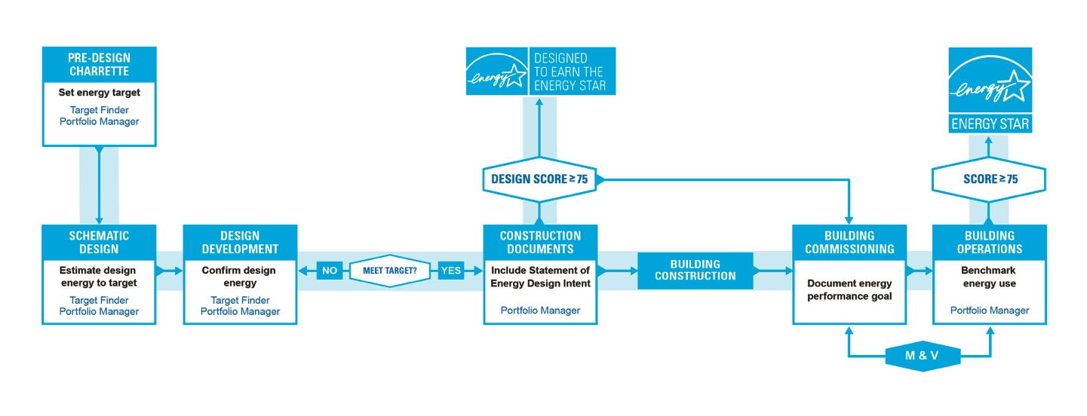

Questions: www.energystar.gov/buildingshelp

An ENERGY STAR score of 75 is the minimum threshold for achieving certification; for design projects the score may be specified higher to allow for changes and fluctuations during construction and operations.
For property types not eligible for ENERGY STAR score, the EPA Portfolio Manager and Target Finder tools may be used to specify and document a target energy use intensity (EUI) by substituting the score specification language with target EUI specification language: “to achieve a target EUI of XX kBtu/sf/year established from the percent better than median property calculation.” However, property types not eligible for an ENERGY STAR score are not eligible for certification.
The Statement of Energy Design Intent for application of Designed to Earn the ENERGY STAR certification must be generated from Portfolio Manager and not Target Finder.
The minimum number of months required to qualify for ENERGY STAR; the number of months specified may be increased to reflect project goals.
The minimum occupancy density required to qualify for ENERGY STAR; occupancy density specified may be increased to reflect project goals.

