Thank you for your participation in this year’s ENERGY STAR Day on Tuesday, October 22, 2019. ENERGY STAR Day brings together the Environmental Protection Agency (EPA) and its partners, as well as individuals across the country, in a celebration of energy efficiency. For ENERGY STAR Day 2019, we encourage you to use social media to raise awareness of the benefits of ENERGY STAR certified products, with a particular focus on providing energy-saving opportunities to underserved audiences that need it the most.
To facilitate your outreach, we have developed this simple toolkit with easy-to-use instructions, messaging, and materials. We look forward to another great ENERGY STAR Day celebration!

Toolkit Table of Contents
- How to Participate
- Creative Assets: video and social graphics
- Sample Social Media Posts

How to Participate
Join us by raising awareness and offering opportunities for your audiences to save for good with ENERGY STAR. The idea is simple. With ENERGY STAR certified products, you can save today with rebates and other deals, save tomorrow with energy savings, and save for good—for all the good things you want in your life and for a healthier planet for you and your family.
Share on social media on October 22nd, 2019.
We encourage all partners to join ENERGY STAR on social media on Tuesday, October 22nd to amplify the ENERGY STAR energy-saving message to the entire country. Let’s see how far our collective voice can reach!
In addition, we encourage you to consider integrating ENERGY STAR Day messaging into any other October outreach activities you have planned.
- When: Tuesday, October 22nd, 2019 (ALL DAY)
- Where: Social media (Facebook, Twitter, Instagram, etc.)
- How: Use the hashtag #ENERGYSTARday

Creative Assets
The ENERGY STAR Day creative assets available for your use include a video and social media graphics.
Video
The ENERGY STAR Day video, “Save Today, Save Tomorrow, Save for Good with ENERGY STAR” is located on YouTube and can be linked to in your social media and other digital promotion.

Graphics
Previews of the graphics are shown below. All the graphics are available free for download here. We have added images specific to product types.
- General
- Lighting
- Smart thermostats
- Appliances
- Water heaters

Sample Social Media Posts
Here are some sample social media posts to promote ENERGY STAR Day along with the video or graphics. When posting ENERGY STAR materials on social media:
  - Include the hashtag #ENERGYSTARday
  - Tag ENERGY STAR when posting on Twitter or Facebook:
    - Twitter: @ENERGYSTAR
    - Facebook: Begin typing “@ENERGYSTAR” and choose ENERGY STAR from the dropdown list; be sure to make the post public
  - Include one of the ENERGY STAR Day images or the video with your posts; if using an image, share at highest resolution possible for each platform

General
Happy ENERGY STAR Day! It's time to celebrate the benefits of energy efficiency with ENERGY STAR. By choosing products that have earned the ENERGY STAR, you'll save today, tomorrow, and for good. #ENERGYSTARday energystar.gov/SaveForGood
The typical household spends about $2,000 a year on energy bills. With ENERGY STAR, you can save 30% or about $575 in household energy costs. Look for the label on lighting, appliances, electronics, heating and cooling equipment, and more. #ENERGYSTARday energystar.gov/SaveForGood
With ENERGY STAR certified products, your energy savings start today, and continue with lower energy bills every day! Save even more with our [DEAL, REBATE, OR SPECIAL INCOME-QUALIFIED PROGRAM]. Visit energystar.gov/SaveForGood to learn more. #ENERGYSTARday
[PARTNER] is proud to celebrate ENERGY STAR Day and help all Americans save for good. See how you can save with ENERGY STAR by checking out our [SPECIAL INCOME-QUALIFIED PROGRAM]. Visit energystar.gov/SaveForGood to learn more. #ENERGYSTARday
Come to [RETAILER] for the best selection of ENERGY STAR certified products. Products that earn the ENERGY STAR label will save energy, save money, and help protect the climate, today and every day! #ENERGYSTARday energystar.gov/SaveForGood
Download zip file of high-res General graphics.

Product-specific posts:
Here are examples of ways to promote your ENERGY STAR certified products and any deals that may be available. If you would like to create your own posts with savings messaging for a specific product, please see our ENERGY STAR Product-specific Savings document.
Lighting
Save today with great prices on ENERGY STAR certified LED bulbs, and save for good with a lifetime of savings. ENERGY STAR certified bulbs use up to 90% less energy than incandescent bulbs, last 15 times longer, and save more than $55 in electricity bills over their lifetime. #ENERGYSTARday
Download zip file of high-res Lighting graphics.
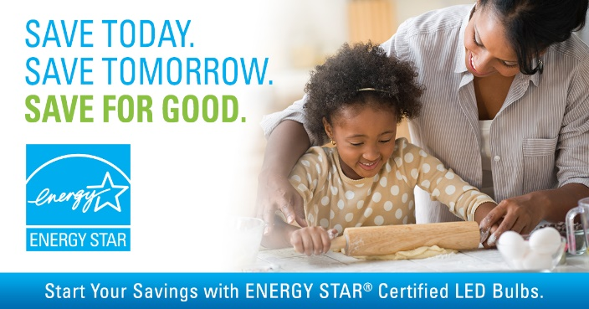
Smart Thermostats
With ENERGY STAR, your energy savings start today, and continue with lower energy bills every day! ENERGY STAR certified smart thermostats are field tested to deliver whole-home energy savings, along with reliable performance, convenience, insight, and control. #ENERGYSTARday | Download zip file of high-res Smart Thermostats graphic.
Appliances
Celebrate ENERGY STAR Day at [RETAILER]. We carry the latest ENERGY STAR certified appliances: clothes washers, clothes dryers, dishwashers, and refrigerators. Choosing a suite of ENERGY STAR certified appliances could save you more than $700 in energy costs over the products’ lifetimes! #ENERGYSTARday | Download zip file of high-res Appliances graphics.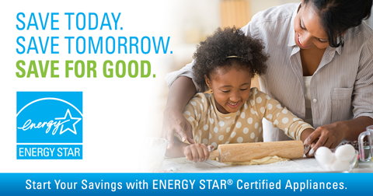
With ENERGY STAR, your energy savings start today, and continue with lower energy bills every day! You can save $380 over the lifetime of an ENERGY STAR certified clothes washer and even more with an ENERGY STAR washer/dryer pair. #ENERGYSTARday | Download zip file of high-res Appliances graphics.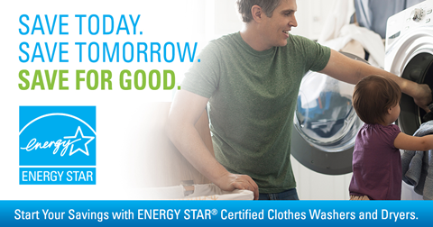
You could save more than $300 in energy costs over the next five years when replacing an old refrigerator with ENERGY STAR. Start your savings today by making the switch. #ENERGYSTARday | Download zip file of high-res Appliances graphics.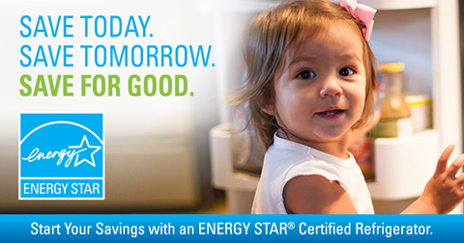
Water Heaters
Start saving today! An ENERGY STAR certified heat pump water heater can save a household of 4 approximately $350 per year on its electric bills compared to a standard electric water heater. Larger families—that typically use more hot water—will save even more. #ENERGYSTARday | Download zip file of high-res Water Heaters graphic.two

