Thank you, foodservice partners and stakeholders, for your participation in this year’s ENERGY STAR Day on Tuesday, October 27th, 2020. ENERGY STAR Day is a celebration of our collective efforts to bring the benefits of energy savings to everyone—helping restaurant operators save today, save tomorrow, and save for good. This year this message has special meaning given the further economic challenges of today. We encourage you to join us in amplifying this important message as part of this year’s ENERGY STAR Day activities.
To facilitate your outreach, we have developed this simple toolkit with easy-to-use instructions, messaging, and materials.
Toolkit Table of Contents
- How to Participate
- Creative Assets
- Sample Social Media Posts

How to Participate
Join us by raising awareness and offering opportunities for all food service operators to save for good with ENERGY STAR. The idea is simple. With ENERGY STAR certified products, customers can save today with rebates and other deals, save tomorrow with energy savings, and save for good—for an improved bottom line and for a healthier planet.
- When: Social media posts on Tuesday, October 27th, 2020 (ALL DAY)
- Where: Includes Facebook, Twitter, Instagram, LinkedIn, etc.
- Use the hashtag and tag: #ENERGYSTARday and @ENERGYSTAR
We encourage all partners to join ENERGY STAR on social media on Tuesday, October 27th to amplify the ENERGY STAR energy saving message to the entire country. Let’s see how far our collective voice can reach!
In addition, we encourage you to consider integrating ENERGY STAR Day messaging into any other October outreach activities you have planned.
Supplemental activities:
- 2020 ENERGY STAR Day Video: Share the 2020 ENERGY STAR Day video!
- ENERGY STAR CFS Tools and Resources: Include links to your favorite ENERGY STAR CFS tools and resources such as Rebate Finder, Dealer/Distributor Finder, Product Finder, Restaurant Guide, and more from the CFS landing page (www.energystar.gov/cfs).
- Feature the ENERGY STAR web banner: In addition, we encourage you to feature one of our web banners on your ENERGY STAR and/or energy efficiency pages during October to celebrate energy-savings and your commitment to bring these benefits to your audiences.

Creative Assets
The ENERGY STAR Day creative assets available for your use include a video, and CFS social media graphics and web banners.
Video
Our 2020 ENERGY STAR Day video, titled “Save Today, Save Tomorrow, Save for Good” is a compilation video featuring real moments and real people enjoying the benefits that their ENERGY STAR certified products provide them. The theme of energy savings for everyone is conveyed through moments and soundbites, curated from a combination of footage and photos provided by ENERGY STAR partners, stock footage, and original content from ENERGY STAR and our communications team. Visit the ENERGY STAR YouTube channel to view and share this video!

Customizable Web Banners
We have a suite of web banners available in three sizes: 300x600, 728x165, and 1032x234. Two of the banners are also available in Spanish.
All the web banners are available free for download as a zip file at energystar.gov/marketing_materials. The design files are customizable so you can include your own name and message.

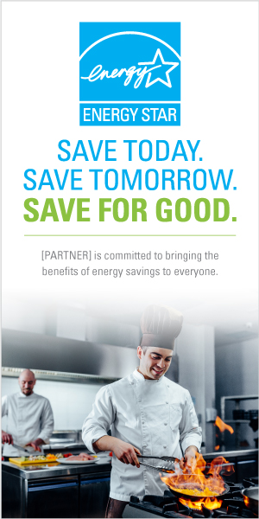
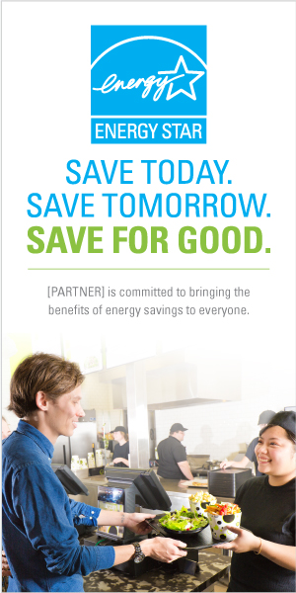
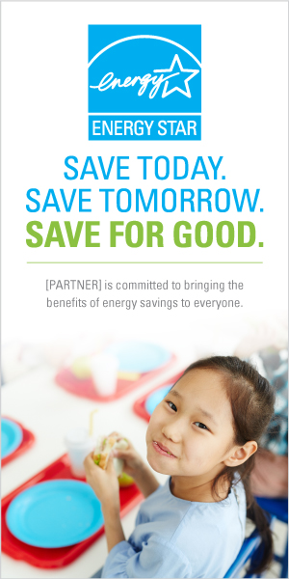
Size 300x600
There are three banners in size 300x600, shown on the right.

Sizes 728x165 and 1032x234
The following three web banners are available in two sizes: 728x165 and 1032x234.
Spanish versions
We have two banners translated into Spanish in size 1032x234.

Graphics
Previews of the graphics are shown below. Six different social graphics are available free for download as a zip file.

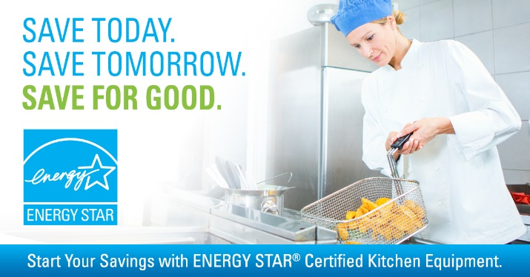
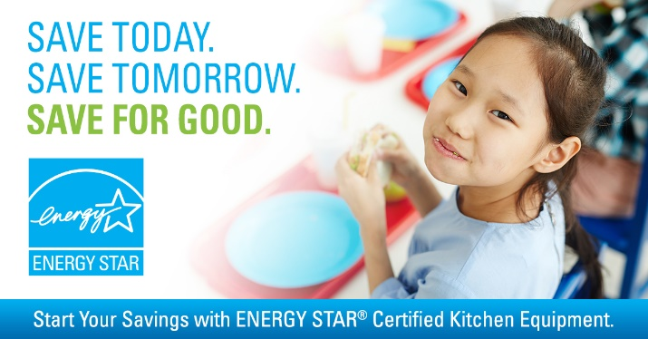
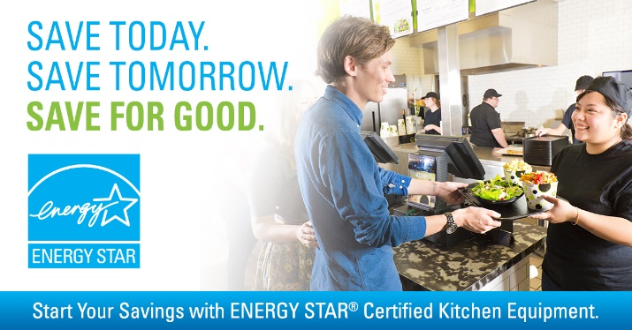
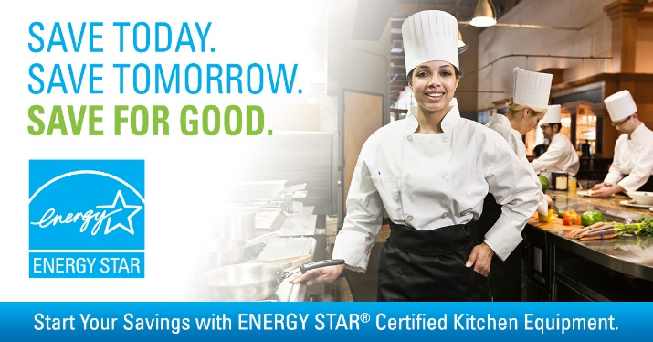
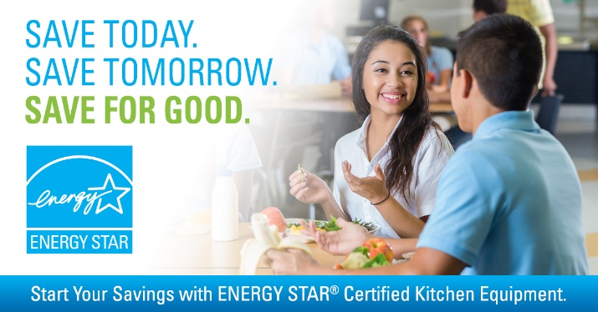

Sample Social Media Posts
Boilerplate language is available in the table below and can be used for your social media posts to promote ENERGY STAR Day along with the CFS graphics and/or ENERGY STAR Day video. Tips for posting ENERGY STAR materials on social media:
  - Include the hashtag #ENERGYSTARday
  - Tag ENERGY STAR when posting on Facebook or Twitter:
    - Twitter: @ENERGYSTAR
    - Facebook: Begin typing “@ENERGYSTAR” and choose ENERGY STAR from the dropdown list; be sure to make the post public
  - Include one of the ENERGY STAR Day CFS graphics (above) with your posts; and share at the highest resolution possible for each platform

For more information on preparing a social media post to capture your audience’s attention, a recording of our webinar ENERGY STAR Day Promotion and Other CFS Tools can be found here.

General
Happy ENERGY STAR Day! It's a great time to celebrate the benefits of energy efficiency with ENERGY STAR. By choosing equipment that has earned the ENERGY STAR, you'll save energy, save money and help protect the climate. #ENERGYSTARday @ENERGYSTAR energystar.gov/cfs
Commercial kitchens are one of the highest energy consumers in buildings using 2-3 times more energy per square foot than other commercial buildings like offices or retail stores. Outfitting a commercial kitchen with a suite of commercial food service equipment that has earned the ENERGY STAR could save an operator more than $5,300 a year on energy bills. Look for the label on commercial food service products such as hot food holding cabinets, ovens, fryers, ice makers, coffee makers and more. #ENERGYSTARday @ENERGYSTAR energystar.gov/cfs
Visit your local [DEALER] for the best deals on ENERGY STAR certified [PRODUCT]. Get low prices now and low energy bills from now on! [PARTNER] is a proud participant in ENERGY STAR Dat. Visit energystar.gov/cfs to learn more. #ENERGYSTARday @ENERGYSTAR
Celebrate saving energy and money on ENERGY STAR Day with great deals on select ENERGY STAR certified [PRODUCT]. Start your savings today and save for good. Visit energystar.gov/cfs to learn more. #ENERGYSTARday @ENERGYSTAR
We’re proud to celebrate ENERGY STAR Day and help all commercial kitchens save for good. With ENERGY STAR certified products, you save energy, save money and help protect the climate. Learn more at energystar.gov/cfs #ENERGYSTARday @ENERGYSTAR
Kitchen equipment that earns the ENERGY STAR is independently certified to save energy, save money and help protect the environment. Learn more at energystar.gov/cfs #ENERGYSTARday @ENERGYSTAR

Product Specific Savings

Hot Food Holding Cabinets
- Product page
- Fact sheet

Commercial Griddles
- Product page
- Fact sheet

Commercial Ovens
- Product page
- Fact sheet

Commercial Coffee Brewers
- Product page

Commercial Steam Cookers
- Product page
- Fact sheet

Commercial Refrigerators and Freezers
- Product page
- Fact sheet

Commercial Fryers
- Product page
- Fact sheet

Commercial Ice Makers
- Product page
- Fact sheet

Commercial Dishwashers
- Product page
- Fact sheet

Vending Machines
- Product page

Water Coolers
- Product page

