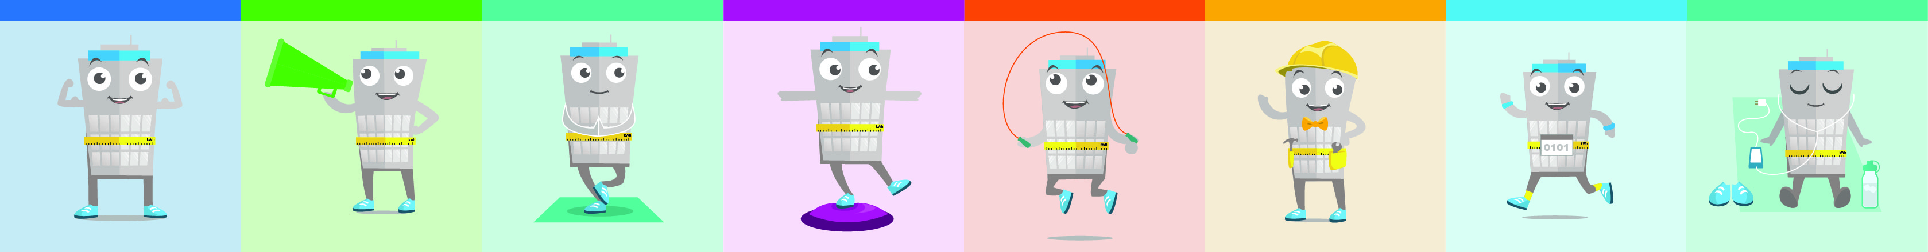

ENERGY STAR® BOOTCAMP Training Plan

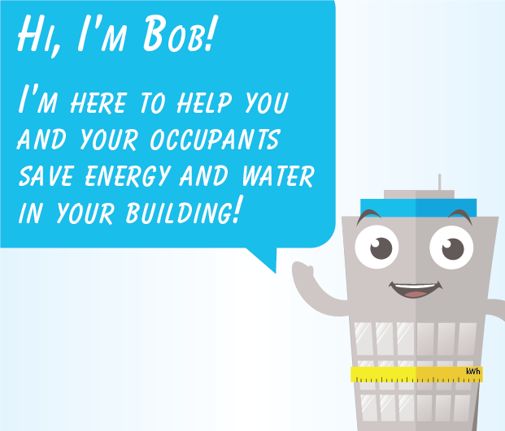
Welcome, BOOTCAMP Competitor!

Over three months, you’ll have the opportunity to build new energy- and water-saving habits that will reduce your environmental footprint and utility costs for years to come. This BOOTCAMP training plan will help you plan ahead to make the most of your participation and the dozens of resources available at your fingertips! All materials listed below are available online at energystar.gov/BattleOfTheBuildings

Pre-Competition | August

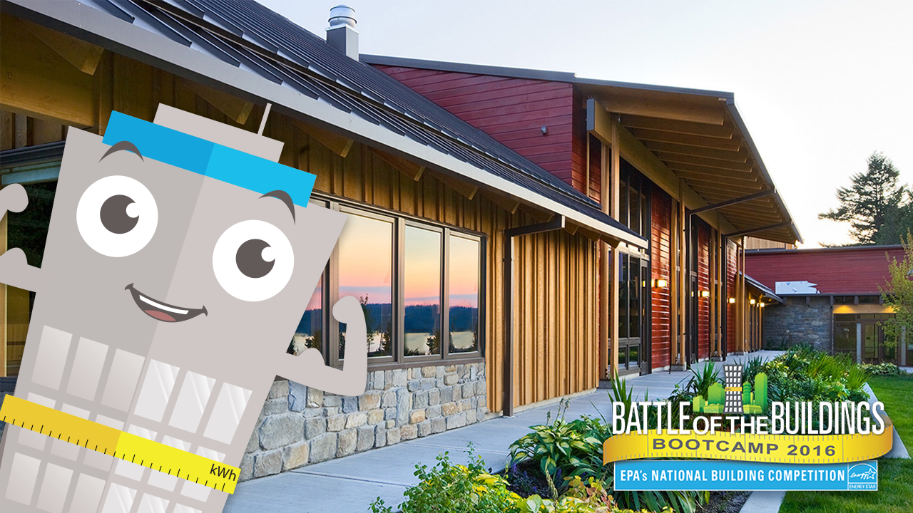
1. Download and use the “We’re Competing!” materials
Tell the world you’re competing! This toolkit includes a print-ready poster and banner, table tents, a social media graphic, web buttons, a template press release, template emails, sample social media posts, and more. You’ll even find a digital Bob “selfie” you can add to a picture of your building!
Download the “We’re Competing” kit.

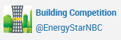
2. Get social
Follow @ENERGYSTARNBC on Twitter and tag your energy-saving efforts with #ESNBC so they’re pulled into our competition Twitter feed! Find sample social media posts in the “We’re Competing” communications toolkit.

3. Download the electronic calendar reminders
EPA will help you focus on a different category of energy waste each month, and practice a different energy exercise each week, by providing a variety of outreach materials. Add these reminders to your calendar (iCal, Outlook, Google, etc.) to get a jump on preparing for each month of the competition.

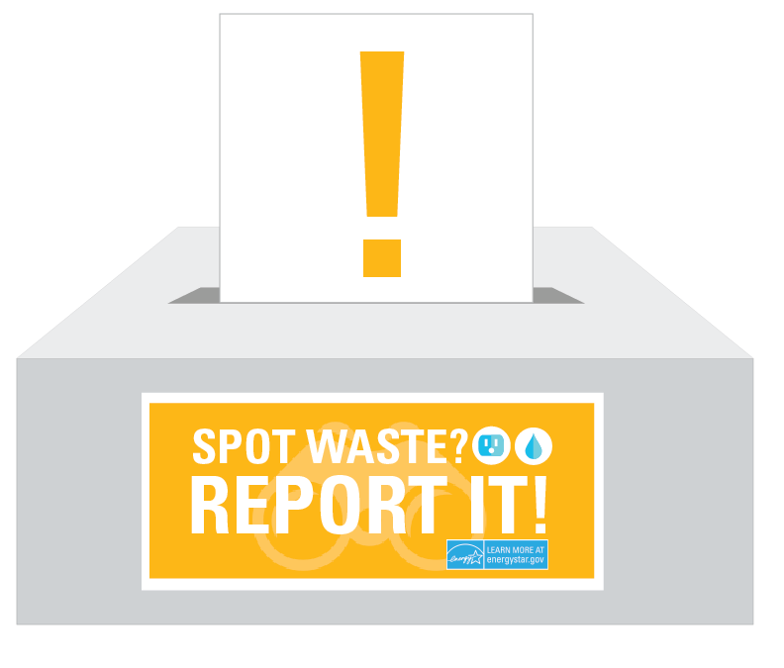
4. Establish communications
Create an email address or place a suggestion box in a common area in your building using the “Report Waste” labels and poster. This allows occupants to be your eyes and ears and notify you if they see energy/water waste they can’t fix on their own!

5. Host a kick-off event
Use the “We’re Competing!” kit materials to decorate your lobby and elevators, and then have a launch event in early September with food or coffee, so you can explain to building occupants what to expect over the next three months, how they can help, and your company’s sustainability goals.

6. Assign roles
Need help keeping things on track? Recruit your green team, sustainability liaison, or an intern to take ownership of your BOOTCAMP participation, print and post materials, and report to you on progress.

Competition Period | September, October, November
EPA will help you focus on a different category of energy or water waste each month, and a different energy-saving action each week. There are more than a dozen actions from which to choose, and more are being added! Follow along below, or pick and choose whatever actions apply best to your building.
One week before each new month, you’ll receive an email reminder about the upcoming focus area, with tips for making the most of your participation, and links to associated BOOTCAMP activity kits. (You can also save the electronic calendar reminders on page 1 to your own calendar.)
Download the BOOTCAMP activity kits here.
Each kit includes a print-ready poster as well as a co-brandable poster with a placeholder for your logo. Small materials like posters and reminders can be printed on a home or office printer. Larger materials, such as the 24x36” poster and 36x60” banner, can be sent to your local print shop. Digital files like social media graphics are also included. And even if there aren’t placeholders, you can always co-brand any and all of these materials!

September: Lighting

Water Wednesdays
In addition to energy-saving actions, EPA will feature simple water-saving actions on periodic “Water Wednesdays” throughout the competition.
All actions are promoted as best practices by EPA’s WaterSense program.
www.epa.gov/watersense
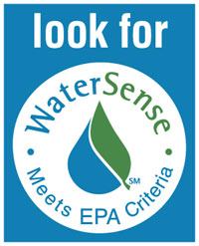

September 1: BOOTCAMP Launches!
September 1: Spotting Energy Waste: Lighting
Monday, Sept 5: Turn off the lights
Wednesday, Sept 7: Spotting Water Waste
Monday Sept 12: Try daylighting
Wednesday, Sept 14: Turn off the tap
Monday, Sept 19: Reach for task lighting
Monday, Sept 26: Try LEDs

October: Plug load
Saturday, Oct 1: Spotting Energy Waste: Plug load
Monday, Oct 3: Activate power-save settings
Monday, Oct 10: Shut it down (computers)
Wednesday, Oct 12: Sweep instead of rinsing
Monday, Oct 17: Look for the ENERGY STAR
Wednesday: Oct 19: Use water-efficient settings
Monday, Oct 24: Unplug unused electronics
Monday, Oct 31: Halloween! Be an energy superhero

November: Heating/Cooling
Tuesday, Nov 1: Spotting Energy Waste: Heating/Cooling
Monday, Nov 7: Use your blinds
Wednesday, Nov 9: Run dishwashers on full
Monday, Nov 14: Unblock vents
Wednesday, Nov 16: Look for WaterSense label
Monday, Nov 21: Skip the space heater
Wednesday, Nov 23: (rerun) Look for the ENERGY STAR (on Black Friday purchases)
Monday, Nov 28: Report temperature imbalances

The competition period concludes on November 30, so be sure to revisit this training plan and your progress frequently to be sure you’re using the materials and getting the most out of your participation!

