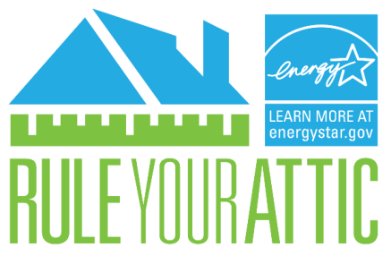
Did you know that 90% of American homes are under-insulated*? This means that 9 out of 10 U.S. homeowners are wasting money on their energy bills.

Check the levels of insulation in your attic to see what work can be done to stop wasting energy, save money, increase your home's comfort, and reduce the pollution that contributes to climate change.
.

- Measure
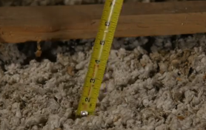
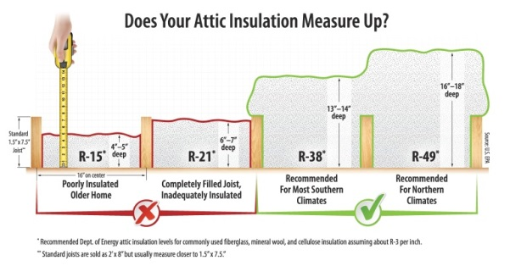

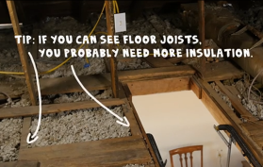

Go into your attic and use a measuring tape or ruler to measure the depth of the insulation in inches. Looking across your attic, if the insulation is level with or below the attic floor joists, you probably need to add more insulation.

- Post
Post pictures and videos of your attic on Facebook, Twitter, or Pinterest or email insulation@energystar.gov to get advice from EPA experts. Tag @ENERGYSTAR and use the hashtag #RuleYourAttic

- Take Action!
Hire a contractor or do it yourself. Visit energystar.gov/ruleyourattic to learn more about air sealing and insulation projects.

*Compared to 2006 IECC standards, Source: Boston University and NAIMA

