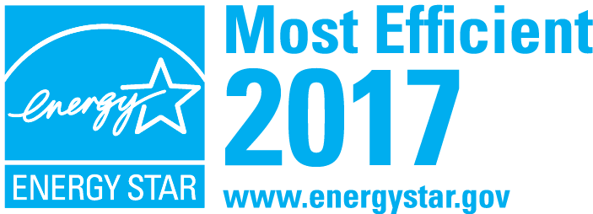
General Messaging
Headline:
ENERGY STAR® Most Efficient 2017:
The year’s best of the best in energy efficiency and innovation.
Copy:
The Environmental Protection Agency’s ENERGY STAR program is America’s recognized authority on energy-efficient products and practices. Looking for the ENERGY STAR label makes it easy to choose products that save money and prevent climate change through greater energy efficiency. Brands from around the globe, and across 70 different product categories, voluntarily submit their products to the rigorous third-party certification process that can earn them the right to bear the ENERGY STAR label.

Each year, EPA recognizes a select group of ENERGY STAR products as the best of the best. Earning the ENERGY STAR Most Efficient 2017 distinction means a product combines cutting-edge energy efficiency with innovative performance and features. It’s an award that highlights the very best of ENERGY STAR.

ENERGY STAR Most Efficient 2017 makes the year’s best-in-class energy efficiency and breakthrough technological innovation a simple choice for those seeking the very best of both.

Visit energystar.gov/mostefficient for a listing of the year’s award-winning ENERGY STAR products in categories that include appliances, televisions, and heating and cooling equipment.
Tagline:
The best of ENERGY STAR for your home and for the planet
Energystar.gov/mostefficient

RADIO AD MESSAGING
Anncr:
Looking for the ENERGY STAR label is a simple way to save money and help prevent climate change. Now EPA introduces ENERGY STAR Most Efficient 2017, awarding the year’s best of the best in energy efficiency and innovation.

Learn more at energystar.gov.

PRINT AD MESSAGING:
Headline:
ENERGY STAR® Most Efficient 2017:
The Year’s Best of the Best in Energy Efficiency and Innovation

Copy:
Looking for the ENERGY STAR label is a simple way to save money and help prevent climate change. Now EPA introduces ENERGY STAR Most Efficient 2017, a new distinction that recognizes select products that deliver cutting edge energy efficiency along with the latest in technological innovation. It is an award that highlights the very best of ENERGY STAR.

POINT-OF-PURCHASE MESSAGING:
Headline:
WHEN ONLY THE BEST WILL DO.
The best of ENERGY STAR for your home and for the planet

ENERGY STAR® Most Efficient 2017

energystar.gov/mostefficient

###

